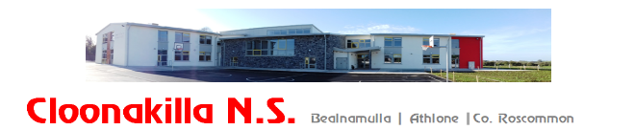
Phone: 090 6492569, email: cloonakillaschool@gmail.com, website: www.cloonakillans.com
Newsletter, November 2025
Dear Parents,
Please find below details of forth coming events in our school and events we took part in:
Carpark
Thank you for your continued co-operation in following the car park guidelines. It is essential that these procedures are followed to at all times to safeguard everyone on the school grounds. A few reminders that I would like to bring to your attention:

- We remind parents not to walk through, or park in, the staff car park when collecting children, as this area must remain clear for school buses.
- All pedestrians should enter and exit using the pedestrian gate at the front of the school, or via the ramp from the main car park. The main school entrance is not to be used by pedestrians under any circumstances.
- Please also note that collecting children from the outer lane of the drive-through is not permitted. Vehicles must be fully stationary in the designated set-down area before children are collected.
- With winter approaching, we remind everyone to take extra care on frosty mornings around the car park, front yard and footpaths. While the paths will be salted, caution is still advised.
We ask all parents to take responsibility in supporting the safe and efficient running of the car park.
Dates for your Diary
Christmas Confessions – Tuesday December 9th
Sacrament of Confirmation: Ss Peter & Paul’s Church - Wednesday, 25th March 2026 @11am
First Holy Communion: Ss Peter & Paul’s Church - Saturday, 16th May 2026 @ 11am
Enrolment forms for both sacraments have been submitted to the parish office.

Admissions 2026/2027
As you are aware, construction has now begun on the new ASD special classes which are due to open in Cloonakilla NS. We are delighted to see this project progressing and we look forward to the valuable support these classes will offer to our school community.
At present, we are awaiting official confirmation from the Department of Education regarding the approved enrolment numbers for these new classes, this may delay the admissions process for 2026/27 for a number of weeks . Until this confirmation is issued, we are not in a position to begin the admissions process for the 2026/27 school year.
Once the relevant information is received, the full admissions schedule and all required documentation will be published on our school website. We kindly ask parents who wish to apply for a place to monitor the website regularly for updates.
All information will be available in due course at: https://www.cloonakillans.com/
Thank you for your patience and cooperation.

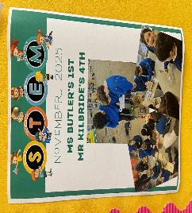
STEM Week
Cloonakilla recently celebrated it’s first-ever STEM Week, combining Maths and Science Week to highlight and develop all things STEM throughout the school. The event provided a wonderful opportunity for pupils to engage in hands-on learning across Science, Technology, Engineering, and Maths.
Both junior and senior classes received tailored homework in the form of activity choice boards, which proved to be a tremendous success. Pupils produced outstanding work, and we extend our thanks to all families who supported the initiative and shared photos of the projects.
Throughout the week, students enjoyed Maths Trails, Tables Champions, Kahoot quizzes, Maths games, and a vibrant Science Fair—ensuring non-stop fun and learning. It was also a great chance for junior and senior classes to pair up, collaborate, and get to know one another through various activities.

IT
Earlier this term, pupils from 4th, 5th & 6th classes were asked to write a letter of application to state reasons why they felt they should be given a position on this year’s “Tech Team”. There were superb entries but in the end, here are the worthy winners.
6th class
Emma Kelly, Emily Dolan, Aoibhinn Mc Gowan, Sophie O Brien, Conor Keegan,Lara Mc Donagh, Sarah Noone & Lauryn Dully
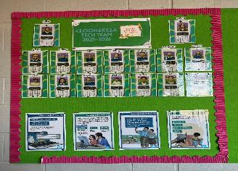
5th Class
Tom Lynam, Andrea Alves Passos, Safiye Connolly & Kayleigh Lynch
4th Class
Carah Robinson, Ellie Doran, Zoe Mc Veigh & Aanvi Chaudhary
They update laptops, allocate distribution sheets, ensure devices are always charged and take good care of equipment. They also aid teachers when distributing Ipads etc.
They hosted a Kahoot quiz to mark STEM Week in November and created their very own questions around the topics of science and maths within our school for both junior and senior classes. It was a great success.
Please take a look at our website to keep up to date with photos of school events. https://www.cloonakillans.com/
If you have a special interest in technology and would like to share your expertise with either staff or pupils, please feel free to contact cloonakillans5th@gmail.com.

Gaelbhratach:
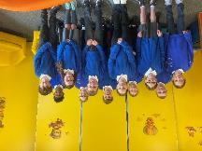
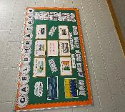
We are delighted to share that Cloonakilla NS is once again participating in the Gaelbhratach initiative this year. This programme encourages the use of Irish in fun, creative and meaningful ways throughout our whole school community. Our mission is to build confidence, pride and positive attitudes towards speaking Irish — both formally and informally. Now entering our second year of the scheme, we are working with great enthusiasm towards achieving our first-ever Gaelbhratach flag! To help lead these efforts, a Coiste Gaeilge has been formed, made up of enthusiastic pupils from 4th to 6th Class. Their role is to promote

informal use of Irish, introduce fun language activities and help make Gaeilge more visible throughout our school. This year, we will continue with some much-loved activities such as:
- Tráth na gCeist – Fun quiz events through Irish
- Amhráin & Rannta – Songs and rhymes to enjoy and share
We are also introducing exciting new targets to help us further promote the use of Gaeilge across the school:

- Gaeilge & Ábhair Eile (CLIL) – Using Irish through other subjects
- Cluichí Clóis – Playground Games as Gaeilge
- Amhrán na bhFiann – Learning and performing our National Anthem
- Foireann Fháiltithe – Irish Welcome Team to greet visitors and promote the use of Irish in school
Junior Infants, Senior Infants, 5th & 6th Classes are currently taking part in the FCÁT scheme through CLIL, completing PE lessons through Irish. They are focusing specifically on orienteering, using Gaeilge as the language of instruction and communication throughout the activities. With the support of our pupils, staff and wider school community, we look forward to embracing these initiatives and seeing Irish come to life in Cloonakilla NS!
Wellbeing:
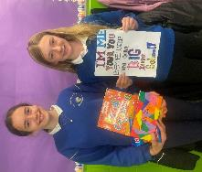
We are delighted to share that a new Wellbeing Committee has been formed in Cloonakilla NS. The committee is made up of enthusiastic and caring students from 5th and 6th Class, who are passionate about promoting kindness, inclusion and positive mental health across our school. The committee has already been very active, holding regular meetings to share ideas and plan activities. Our wellbeing launched the wellbeing slogan competition throughout the whole school. The winning slogan was “I’m me, you’re you, everyone is unique in our big happy school.” Congratulations to our winner Esmee Maher in 6th Class. One of the committee’s key responsibilities is ensuring that Wellbeing Wednesday takes place every second Wednesday, giving all pupils the opportunity to take part in mindfulness, positivity and friendship-building activities. The Wellbeing Committee have also updated our Wellbeing Display Board, with a special focus on feelings and emotions. Inspired by the movie Inside Out, the display explores different emotions, how they may make us feel and positive ways to understand and manage them. It encourages pupils to recognise their feelings, talk about them and learn strategies to cope with them in a healthy way. At the moment, the committee is very busy planning our Annual Wellbeing Advent Calendar, packed with thoughtful and festive activities to help everyone get into the Christmas mood while promoting happiness, gratitude, kindness and connection. We are very proud of the work our Wellbeing Committee is doing and look forward to seeing their wonderful ideas come to life throughout the school year.

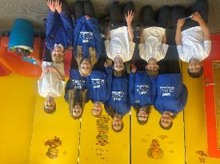

Student Council
The Student Council have been working hard gathering suggestions from pupils across the school on ways we can continue to improve our school community. They are also planning a new student newsletter to keep all classes up to date on school news and upcoming events. In addition, preparations are underway for the Christmas Bake Sale, which will take place on Friday, 5th December. Pupils from 1st to 6th Class are invited to bake goodies to sell, and all children will have the opportunity to buy some tasty treats. All proceeds from the sale will go towards future school improvements, which will be decided by the Student Council and their mentors in the new year.
Special Educational Needs (SEN)
The SEN team are working with class teachers and pupils to support literacy and numeracy throughout the school through a number of initiatives. Guided Reading is supported from 1st class to 6th class. Literacy Lift Off is being delivered to 1st Class in Term 1. It will move to Senior Infants in Terms 2 and 3. The Reading Recovery Programme is also offered to children with emergent literacy needs. Mrs McCabe is our Reading Recovery Teacher. The SEN Team also respond to and support children with social, emotional and behavioural needs with transient to long term interventions. We appreciate the ongoing support of parents which adds to the success of all these initiatives. Under
The National Educational Psychological Services (NEPS) Dr Mary Kate Roche continues to work with us to support teaching and learning in our school. Children who receive a diagnosis during the school year are monitored and can be placed on the Continum of Support at a level that best meets their needs be that Classroom Support, School Support or School Support Plus.

Local History
3rd - 6th classes have been studying the history of our local area as part of the History Curriculum with heritage expert Martin Curley. Martin led them on historical trails of the local area which included fieldtrips to significant historical features such as Meehambee Dolmen, Athlone town and it’s surrounds.
Senior Infants, 1st & 2nd classes completed nature trails within their immediate school environment. Study of local history enables pupils to investigate and learn about the past and to form connections between past and present.

Buddy Programme
Cloonakilla operates a Buddy Programme for the first term each year. A rota is formed so that 6th class children can assist our new junior infants in managing the playground. They ensure that the younger children learn to play with their classmates and join in games. Each 6th class volunteer follows the Buddy Guidelines which are outlined clearly at the start of the term.
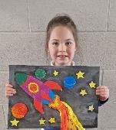
Credit Union Art Competition
Congratulations to Karolina Fahy in Senior Infants, who achieved 3rd place in her category in the Credit Union Art Competition! This year’s theme was “The Future is…”. Karolina’s wonderful artwork earned her a prize, which she will receive on December 2nd. We are all so proud of this budding artist here in Cloonakilla NS!

Hoodies
In keeping with Cloonakilla N.S tradition, our 6th class students received their new personalised school hoodies before mid-term break which they can wear in lieu of their school uniform jumpers.

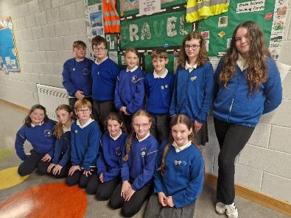
Green Schools
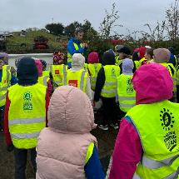
Cloonakilla NS is ready for another great year working on our Green Schools Travel theme. Introducing our new committee! This dedicated group of pupils and our whole school community will work together to promote sustainable travel in our school community. Throughout the year, the committee will gather ideas, run surveys, organise events, and encourage everyone to walk, cycle, scoot, park-and-stride, or use public transport where possible. They will help raise awareness about road safety, reduce traffic around the school, and inspire greener habits that benefit our environment. We’re looking forward to another positive and eco-friendly year ahead!
Travel - Big Travel Challenge
We recently took part in the Big Travel Challenge Competition. A huge thank you to everyone who walked, cycled, and scooted to school, your efforts made a real difference. Our results have now been submitted to the competition. We would also like to acknowledge the fantastic support of our Active Schools and Wellbeing Committees, who worked closely with our Green Schools team throughout the challenge. Their help in promoting active travel, encouraging participation, and spreading positive messages about health and wellbeing played a key role in making the challenge such a success
Litter & Waste
Lunchtime litter picking has commenced in our school, and pupils from 2nd, 3rd, and 4th class have done excellent work in keeping our yard tidy over the past few months. We kindly remind everyone to take home
their rubbish from break and lunch every day. Reducing waste is an important part of keeping our school environment clean.

Biodiversity Workshop – Green Schools Travel Co-Ordinator Ciaran Hussey
2nd classes took part in a wonderful workshop with Ciaran Hussey in October. During his visit, the children enjoyed a nature based session followed by an engaging nature walk around our school grounds. Ciaran helped the pupils explore the plants, insects, and habitats that exist right on our doorstep. The workshop also gave us an opportunity to revisit and deepen our understanding of our Green Schools theme of biodiversity, highlighting the importance of caring for and protecting the natural world around us.

Travel – Road Safety
Please take a few moments to talk to your children about road safety. It’s a key focus of our Travel Theme, and together we can help keep everyone safe on their way to and from school. Please see last page for Road Safety Rules.

Christmas
Christmas Show for Senior Infants
Senior Infants will attend a Christmas Show “I want a Hippopotamus for Christmas” in Dean Crowe Theatre on Tuesday, December 9th. Class teachers will furnish you with exact details.
There will be no Christmas concerts this year as they are held on alternate years. However a programme of events will be held in the school.

Sport
Active Schools: Skip Around The World Challenge:

Active children learn better. Our school reinforces the message that children require 60 minutes of moderate to vigorous physical activity every day. Five minutes of movement between lessons can have a hugely positive impact on the teaching and learning in the lesson that follows. It helps children to adjust energy levels, restore concentration and self- regulate emotions.

In October the whole school participated in the Skip Around The World Challenge. This challenge saw all pupils complete daily skipping breaks to reach designated countries around the world. A big well done to all the children for their efforts during this challenge.
Gaelic
Gaelic coaching with Clann na nGael has commenced on Wednesdays for the senior and middle classes. 4th and 5th classes are currently enjoying perfecting their football skills with Paul Mc Manus.
Rugby
Rugby training is also up and running with Micháel Glennon from Connacht Rugby. Both 6th classes had great fun playing tag rugby up until Mid-Term. Both 3rd classes are now working with Micháel each Tuesday.
Take Over Table Tennis
As part of Active Schools, the Active Schools Committee organised a fun two day event titled Take Over Table Tennis . This event took place on Thursday and Friday November 27th and 28th. The aim of this event was to promote movement, fun and inclusiveness. We hope all the children enjoy playing table tennis with their friends.
Swimming
Swimming will commence on January 9th for an 8 week period. It will be offered to 3rd class first. Parents will be furnished with details nearer the time.
Cross Country
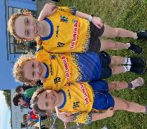
Summerhill NS hosted their annual cross country competition on Wednesday, 24th September, with five local schools taking part: Summerhill NS, Cornafulla NS, Ardkeenan NS, Clonown NS, and Cloonakilla NS. A total of 150 pupils participated in what was a wonderful sporting occasion.
Cloonakilla was proudly represented by 31 pupils who not only demonstrated fantastic athletic ability but also behaved impeccably throughout the event. We are extremely proud of all who took part—and we are delighted to share that several pupils brought home prize

3rd Class Girls
1st – Hannah Lennon
2nd – Polly Dignan
3rd – Peaches Shine
4th Class Boys
1st – Jack O’Neill
2nd – Aaron Kelly
3rd – Charlie Lyons
5th Class Girls
3rd – Saoirse Rushe

6th Class Girls
1st – Emma Kelly (tie)
6th Class Boys
2nd – Christopher Keleghan
3rd – Kayden Costello
A huge well done to all participants for their hard work, teamwork, and excellent representation of our school.

County Cross Country Competition
On Wednesday, October 1st, 24 pupils proudly represented Cloonakilla at the County Roscommon Primary Schools Cross Country Championships. With almost 1,000 pupils from more than 50 schools taking part, the competition was fierce—but Cloonakilla’s athletes rose to the challenge with remarkable resilience, stamina, and team spirit.
We are delighted to share that nine of our pupils earned medals and qualified for the Connaught Cross Country Championships in Loughrea on Saturday, October 18th. Congratulations to our individual medal winners:
Jack O’Neill – 4th place (3rd & 4th Class Boys)
Aaron Kelly – 6th place (3rd & 4th Class Boys)
Emma Kelly – 8th place (5th & 6th Class Girls)

Christopher Kelleghan – 5th place (5th & 6th Class Boys)
Kayden Costello – 7th place (5th & 6th Class Boys)
We also extend a huge well done to our Boys’ Team, who secured 3rd place and advanced to the Connaught Final. Congratulations to Christopher Kelleghan, Kayden Costello, Shane Grogan, Kai Costello, Zach Lennon, and Szilvester Krisztin on this fantastic achievement.

All of our teams performed brilliantly on the day:
3rd & 4th Class Girls: 8th out of 37 teams
3rd & 4th Class Boys: 6th out of 34 teams
5th & 6th Class Girls: 11th out of 38 teams

These are outstanding results, and we are incredibly proud of every pupil who took part. Their determination, teamwork, and school spirit shone throughout the event. Well done to all!
All participants ran exceptionally well in the Connaught Competition, and we offer a sincere thank you to all who kindly transported pupils to the event. Your support—especially on a weekend—was greatly appreciated.

Annual Review of Policies
The Board of Management’s annual review of the school’s and Child Safeguarding Statement was completed at the Board of Management meeting on 6th October 2025.

Policies under Review
We are pleased to inform you that a new page has been added to our school website to facilitate feedback on policies currently under review. This dedicated page can be found under the ‘Policies’ drop-down menu.
Parents are warmly invited to share their feedback on any policy listed on this page. All feedback can be submitted by email to: cloonakillansfeedback@gmail.com

At present, we are in the process of updating our Admissions Policy to include provision for the ASD Special Classes scheduled to open in the 2026/27 school year. Further information on this review is available on the school website.We encourage parents to visit the site regularly for updates and opportunities to contribute.

Parents’ Association
Following this year’s AGM the PA committee is:
Chair: Catherine Hogan, Vice-chair: Joanne Dolan, Secretary: Clare Lennon, Vice Secretary: Michelle Igoe, Treasurer: Lisa Byrne, Vice Treasurer: Roisin Kelly

On behalf of the school community, I would like to offer our sincere thanks to the outgoing Parents’ Association Committee for their hard work and support throughout the 2024/25 school year. We are extremely grateful to Chair – Lisa Byrne, Vice-Chair – Joanne Dolan, Secretary – Christina Melican, Vice-Secretary – Mary Lynam, Treasurer – Becky Garman, and Vice-Treasurer – Catherine Hogan.
Their commitment, time and dedication have made a significant contribution to the life of our school, and we deeply appreciate everything they have done.
We wish the incoming committee every success in their tenure and look forward to continuing the strong partnership between parents and the school in supporting the children of our community.

Yours sincerely,
Mr Kelly, Principal

Cloonakilla NS Rules of the Road
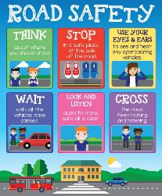
- Always Look Both Ways Before Crossing the Road
"Before you cross the road, stop at the path, look left, right, and left again to make sure there are no cars coming. This is called ‘looking both ways.’ If a car is coming, wait until it’s gone before you cross."
- Use Pedestrian Crossings
"When you need to cross the road, always use a zebra crossing or a pedestrian crossing if there’s one nearby. Cars know to stop at these crossings to let you cross safely."
- Wait for the Green Pedestrian Light
"At traffic lights, always wait for the green pedestrian light before crossing. If there’s no green light, wait and be patient. When the light is green, that’s your sign to go!"
- Don’t Play Near Roads
"It’s fun to play outside, but you should never play near the road. Cars might come suddenly, and you could get hurt if you’re not paying attention."
- Be Seen! Wear Bright Clothing
"When you’re out walking or biking, especially at night, wear bright clothes or something that glows in the dark. This helps drivers see you better."
- Always Wear a Helmet on Your Bike
"If you’re riding a bike, scooter, or skateboard, always wear a helmet to protect your head. If you fall, the helmet can stop you from getting hurt."
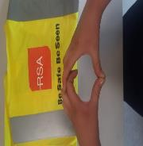
- Stay on the Path
"When you walk, always stay on the path. If there’s no path, walk on the edge of the road facing traffic so you can see the cars coming."
- Don’t Run Across the Road
"Never run across the road, even if you’re in a hurry. Running can make it hard to see cars and be safe. Always walk, and take your time."
- Wait for the Car to Stop Before You Cross
"When you’re walking across the road at a crossing, wait for the cars to completely stop before you step onto the road. Don’t step out until the cars have stopped moving.”

