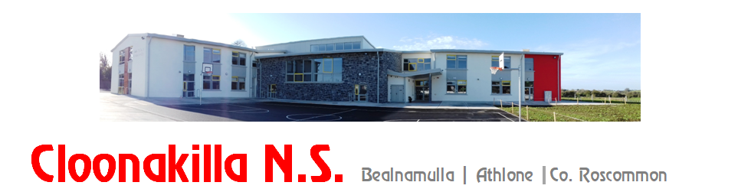
Phone: 090 6492569, email: cloonakillaschool@gmail.com, website: www.cloonakillans.com

Initial Application for Admission 2026
Is this application for: Mainstream ⎕ or Special Education Class (ASD) ⎕
Junior Infant Class ⎕ Other: ⎕ (if other) State Class: _____________________
Surname of Child: ________________________ First Name: ______________________________
Date of Birth: ___________________
Home Address: _________________________________________________________________________________
Eircode: ______________________________
Parents’/Guardians’ Names:
_______________________________________________________________________
Brothers/Sisters in Cloonakilla NS (if any):
__________________________________________________________________
Mother’s Mobile: _________________________Email: ______________________________________
(Block letters please)

Father’s Mobile: _________________________Email: ______________________________________
(Block letters please)

Parent’s /Guardians Signature: ____________________________________

Parent’s /Guardians Signature: ____________________________________

Date: ____________________________________

