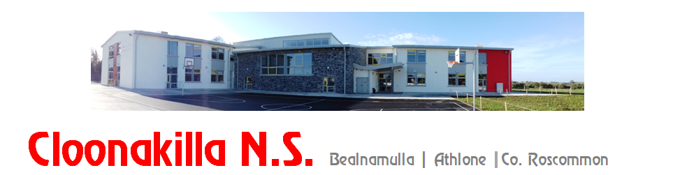
Phone: 090 6492569, email: cloonakillaschool@gmail.com, website: www.cloonakillans.com

Initial Application for Admission of New Pupils for Junior Infants 2023

Name of Child: __________________________________________ Date of Birth: _____ ___________________
Home Address: ___________________________________________________________________________
Eircode: ______________________________
Parents’/Guardians’ Names: _______________________________________________________________________
Brothers/Sisters in Cloonakilla NS (if any):
__________________________________________________________________
Mother’s Mobile: ________________________________ Email: ______________________________________
Father’s Mobile: _________________________________ Email: ______________________________________

Parent’s /Guardians Signature ____________________________________

Parent’s /Guardians Signature ____________________________________

Date: ____________________________________

